26/05/2025
The Manager,
Premium Trust Bank,
Ilorin,
Kwara State.

LETTER OF INTRODUCTION & ACCOUNT MANDATE CHANGE
Dear Sir/Madam,
We write to formally introduce the following individuals as the authorized signatories to our account with your bank:
- Temiloluwa Kolawole – Signatory A
- Zumah Yahaya – Signatory B
Kindly update your records to reflect the following signatory mandate:
- For transactions below ₦500,000 (Five Hundred Thousand Naira), either A or B may sign individually.
- For transactions ₦500,000 and above, both A and B must sign jointly.
Thank you for your assistance.
- Cornelius Oluwasegun Adebayo Director
- Abdulmajeed Abdullahi Director

Thank you for your usual co-operation.
For: Ilorin Tech Park Ltd (Ilorin Innovation Hub)
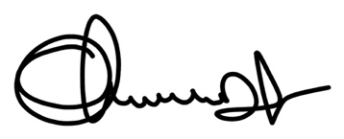
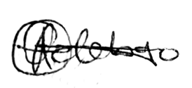

................................................ ............................................
Cornelius Oluwasegun Adebayo Abdulmajeed Abdullahi
Director Director

